SE Project

User Guide for Mow-E V1.0

Raj Sakhrekar

Nishanth Delavictoire

Aim and Audience

This user guide aims to help the user operate and monitor the various functionalities of the onboard as well as the web-based interface for Mow-E 1.0. Understanding this document requires no prior knowledge of any sort of programming or specific software. Any average user familiar with a standard PC Operating System and standard web browsers such as Google Chrome, Microsoft Edge, etc. should be able to understand and successfully utilize Mow-E’s capabilities without a hitch. Let’s get started!

Table of Contents

Disclaimer 2

Getting Familiar with Mow-E 3

Swapping Batteries 4

Onboard HMI 5

Web-based Interface 7

Web-based Interface for Smartphones 12

Troubleshooting 13

Safety and Warnings 15

# Disclaimer

**Before you begin**

1. Read this Safety Manual carefully before operating the mower to become familiar with its controls and proper use.

2. Never allow children, persons with reduced physical, sensory or mental capabilities or lack of experience and knowledge or people unfamiliar with these instructions to use the machine. Local regulations may restrict the age of the operator. You are responsible for accidents or for harm to other people or their property.

3. It is your responsibility to inform your neighbors about the risks, and that it is forbidden to enter your lawn while the mower is operating.

4. If your lawn is open to the street and/or your neighbors, you must be present during the mower’s operation to prevent others from accessing your lawn. Alternatively, you must protect/fence your lawn so that others do not access the mower during operation

# Getting Familiar with Mow-E

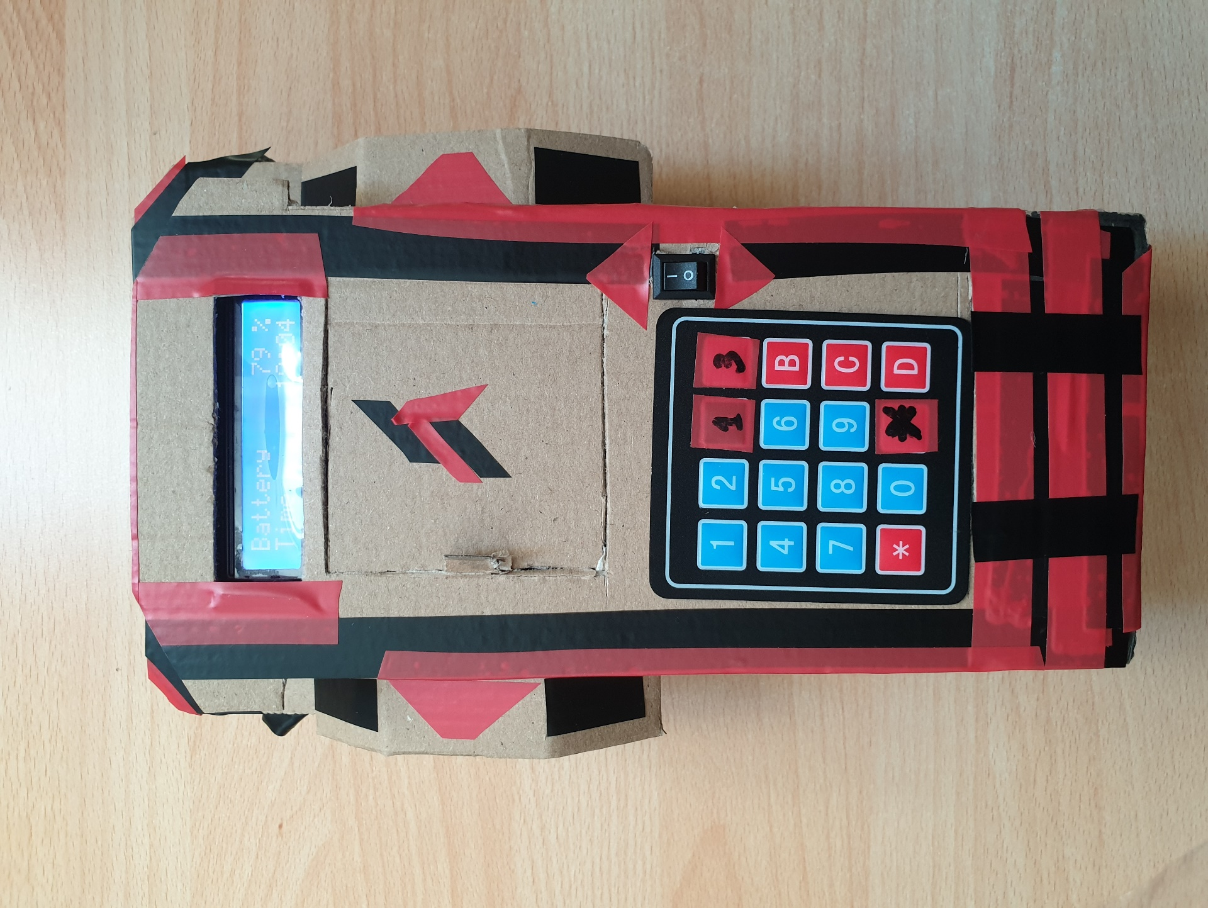

Battery Hatch

Onboard LCD

Start/Emergency Stop Switch

Input Keypad

# 

# Swapping Batteries

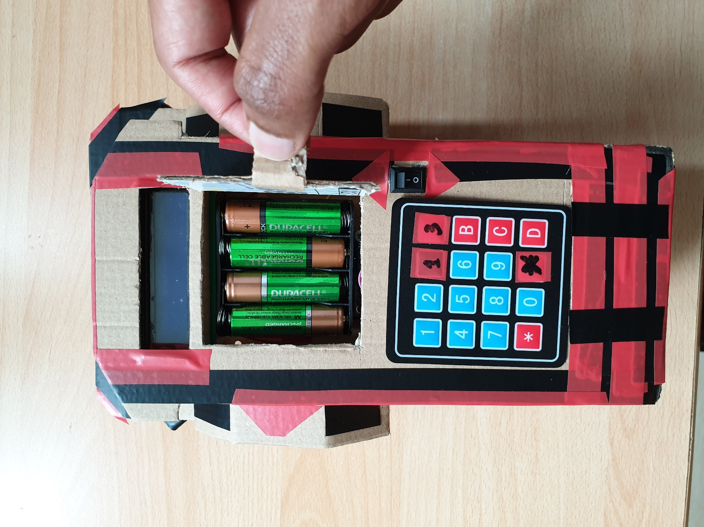

Displayed on the onboard HMI and web-based interface, is Mow-E’s battery level status. Mow-E will return to its dock whenever its battery is low, for easy access.

Open the hatch by pulling gently on the lever. Inside you will see 4 AA batteries that can be recharged, or swapped out for regular AA batteries. We recommend recharging the given batteries for optimal performance.

Make sure to switch OFF the bot before swapping the batteries. Even though the voltage is not strong enough to cause any harm, we would advise against it.

# Onboard HMI

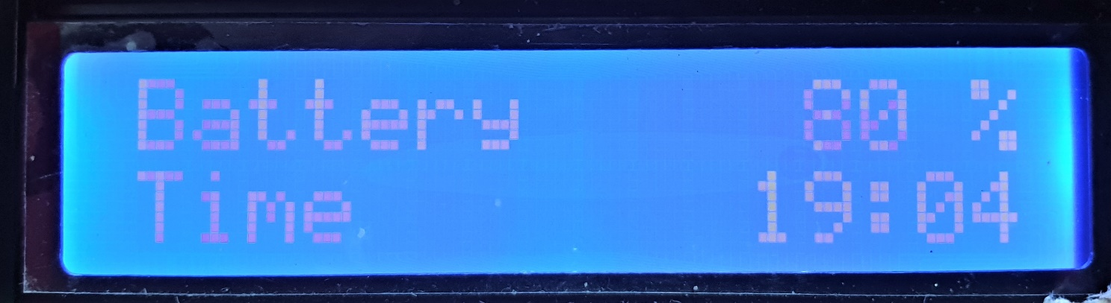

The onboard LCD is a two row display for all interaction and status information. When you are not interacting with the onboard HMI, this display shows the battery level and current, so that you can monitor Mow-E’s status at all times.

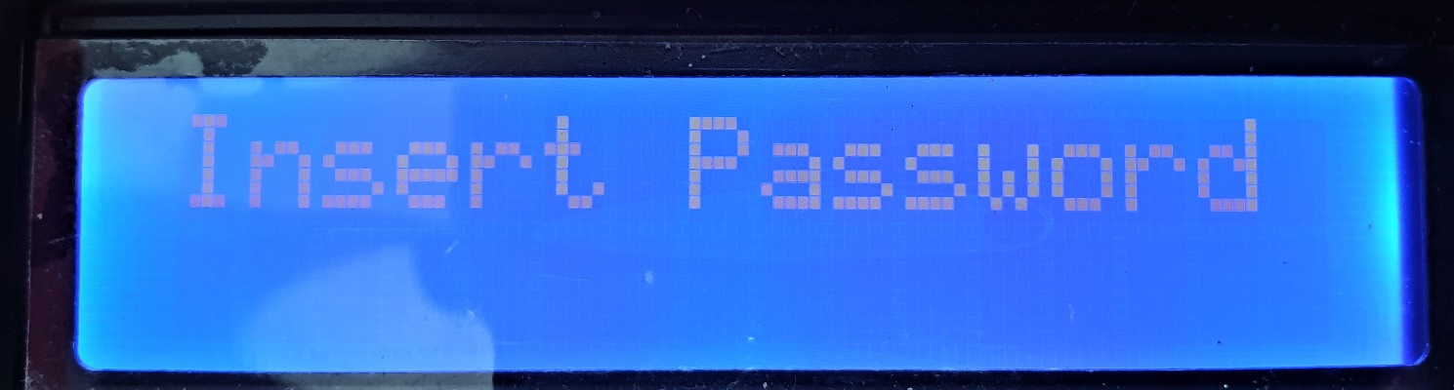

On any keypress, Mow-E will ask you for your password. Any operation from the onboard HMI is protected behind this password, so you can rest easy when it comes to its security.

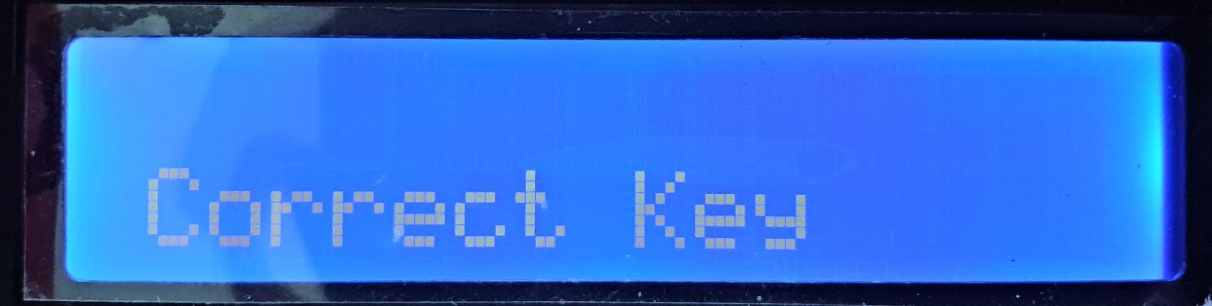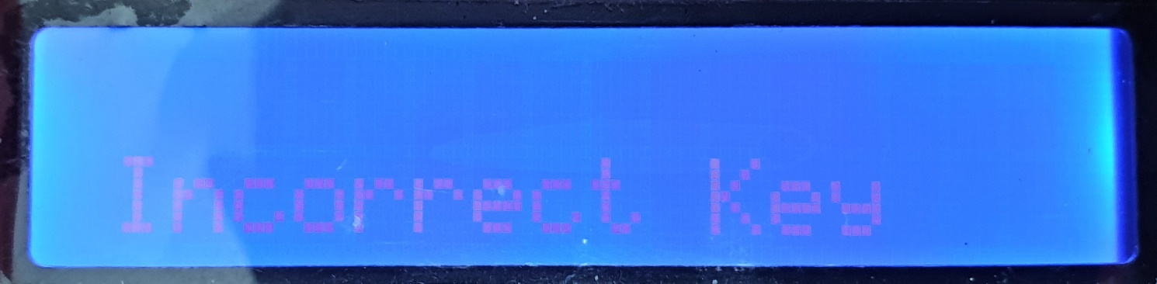

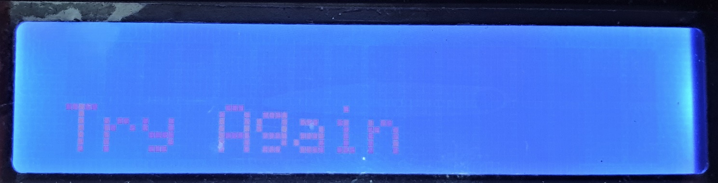

After putting in the password press “C” for check, and depending on whether the password is correct or not, the display will show Correct or Incorrect Key respectively. If the password entered is incorrect, it will ask you to try again. Clicking the * key will also reset the interface and you can enter your password again.

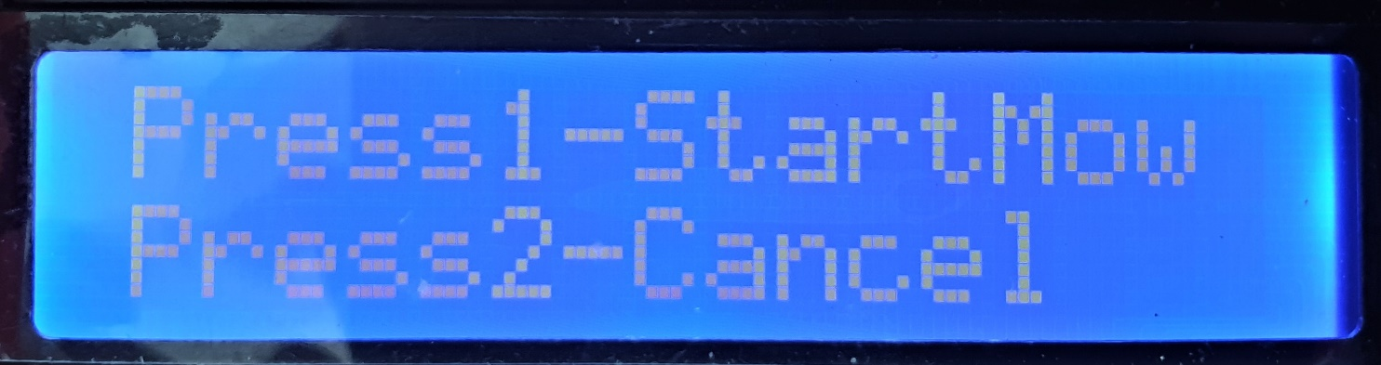

Once the correct password is entered, the interface will ask you to confirm if you want to start the mowing process or cancel. If cancelled, Mow-E will display the battery and time and will be idle. Once you confirm, Mow-E will start the mowing process immediately and display the battery and time during the process.

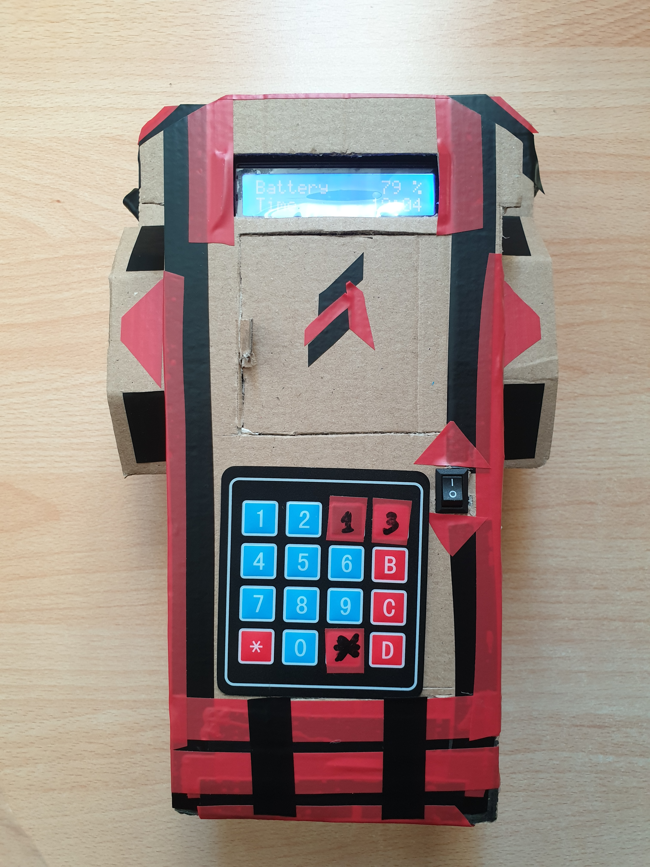

The emergency stop can be used anytime during the mowing process to stop the mowing process.

# 

# Web-based Interface

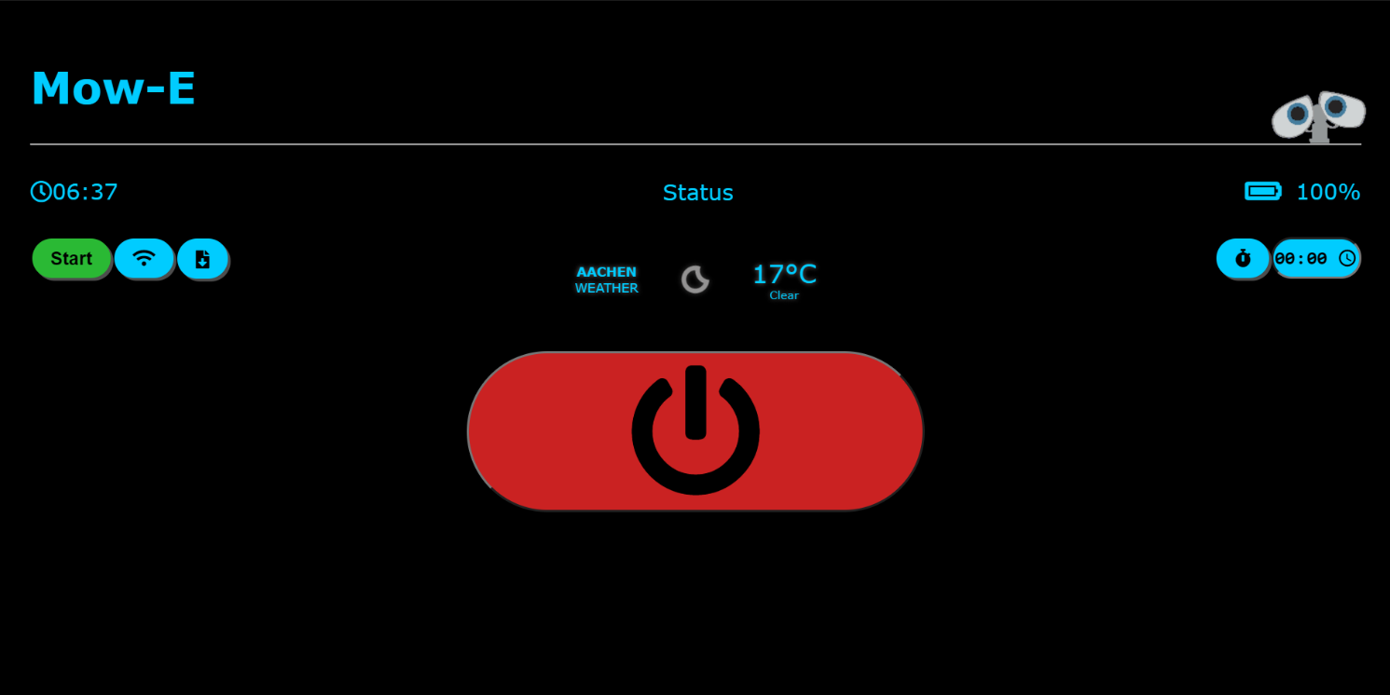

The desktop UI gives you quick and easy access to all functions with one touch interaction.

1. Status Bar

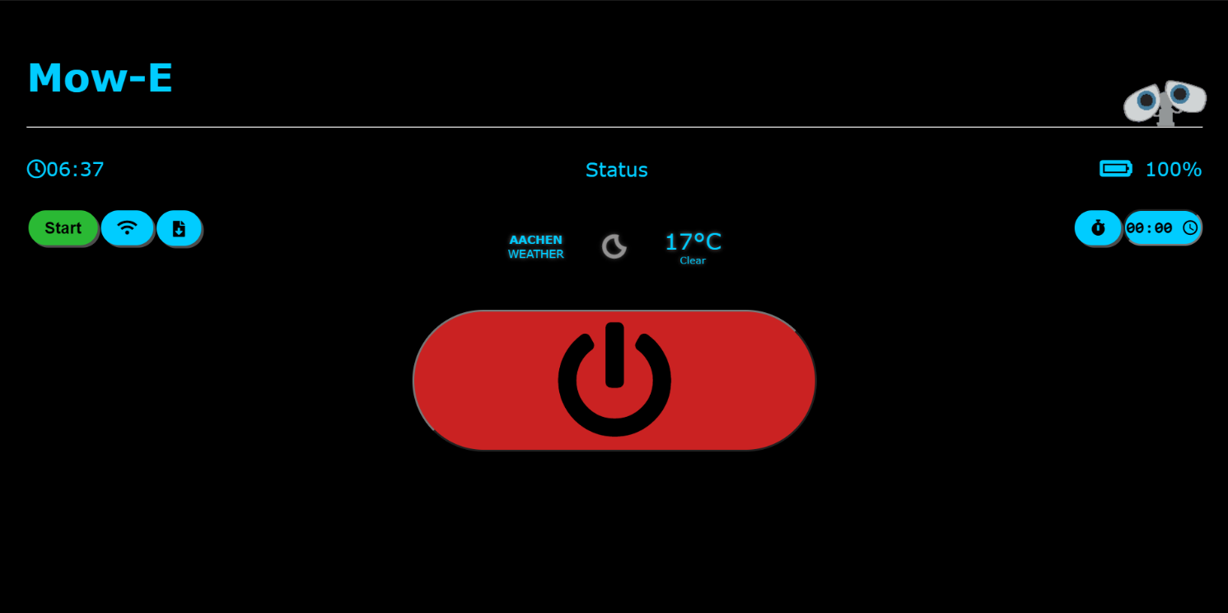

As is clearly visible, the real-time clock, the status of operation and dynamic battery level feedback from Mow-E is displayed in the status bar, enabling the user to constantly monitor Mow-E’s status and vitals. The status and battery level don’t show anything on startup, and will update as the connection to Mow-E is established.

* Status Indicator:

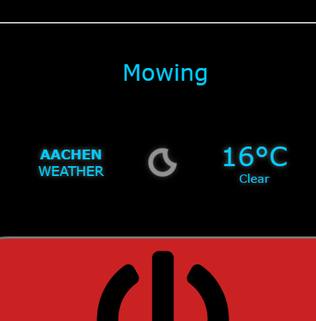 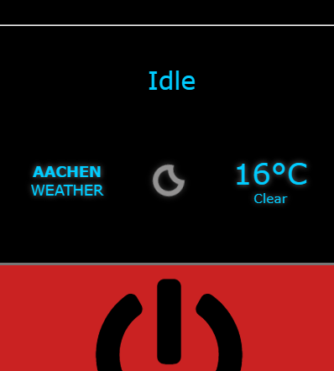 

* Dynamic Battery Level:

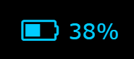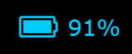

2. Control Centre



All interactions will take place here. Following are the available functions:

* Start – commands Mow-E to immediately start mowing
* Connect to Server – needs to be initialized at the start
* Download Session Report – saves session reports as an html file
* Weather widget – gives an idea to the user about weather conditions
* Scheduler – instructs Mow-E to start mowing at specified time

Let’s dive into these functions a little deeper and understand how it all works.

* To start the interface, open the html file using a standard web browser with an active internet connection.

After opening it, as the UI connects to the server, you should see this screen:

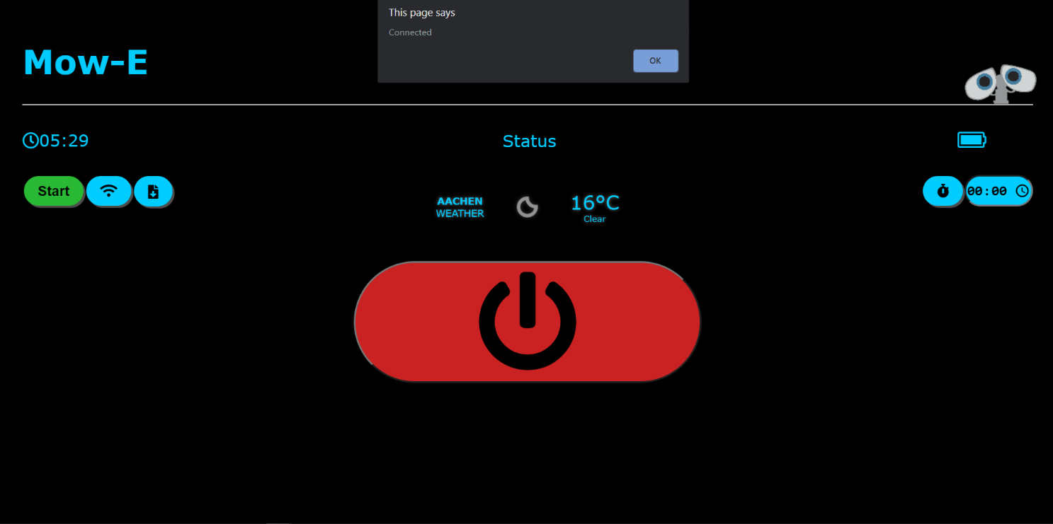

The “Connected” alert indicates that the UI is ready to send messages.

* Connect to Server:

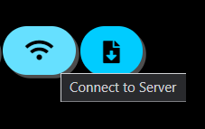

Click the Connect to Server button (with the WiFi icon) to enable the UI to receive messages from Mow-E. This needs to be done after every page refresh/restart.

Now that the communication to and from Mow-E is working, let’s see the actual functions.

* Start:

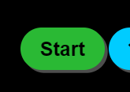

Marked in green to stand out, this button provides the most basic functionality of instructing Mow-E to start the mowing process.

* Emergency Stop:



The Stop or Emergency Stop button, instructs Mow-E to stop mowing. It is enlarged and marked in red so that it is quickly accessible.

* Scheduler:

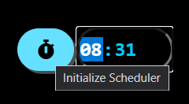

This feature enables the user to set the starting time for the mowing process. First you must input the required time when you wish for Mow-E to start. The default value is set to 12:00 AM. Now, click the Initialize Scheduler button next to the time field (with the timer icon) to activate the scheduler. Once activated, you don’t need to activate the scheduler again as long as the page isn’t being refreshed/restarted. Thus, if you need to change your mowing time after setting up the scheduler, you need only change the time input.

* Download Session Report:

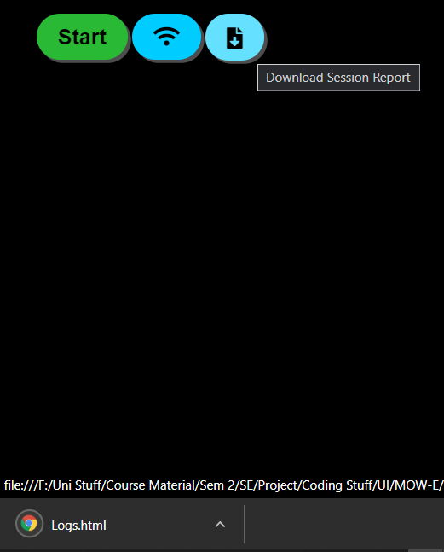

This feature offers the option to save Mow-E’s activity within the current session into a text or html file, for further monitoring or maintenance. We will be saving it to an html file, which can be viewed in the same web browser.

The activity log will show the operation states of Mow-E in the current session, along with a timestamp, as:

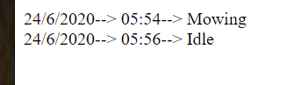

* Weather Widget:



This widget gives the current weather info for the specified location. This can be very helpful and can serve as warning about whether Mow-E should be in operation in case of unsuitable weather conditions, such as rain. This widget is taken from <https://weatherwidget.io/>. Clicking on the widget will redirect you to their website showing a more detailed forecast.

# Web-based Interface for Smartphones

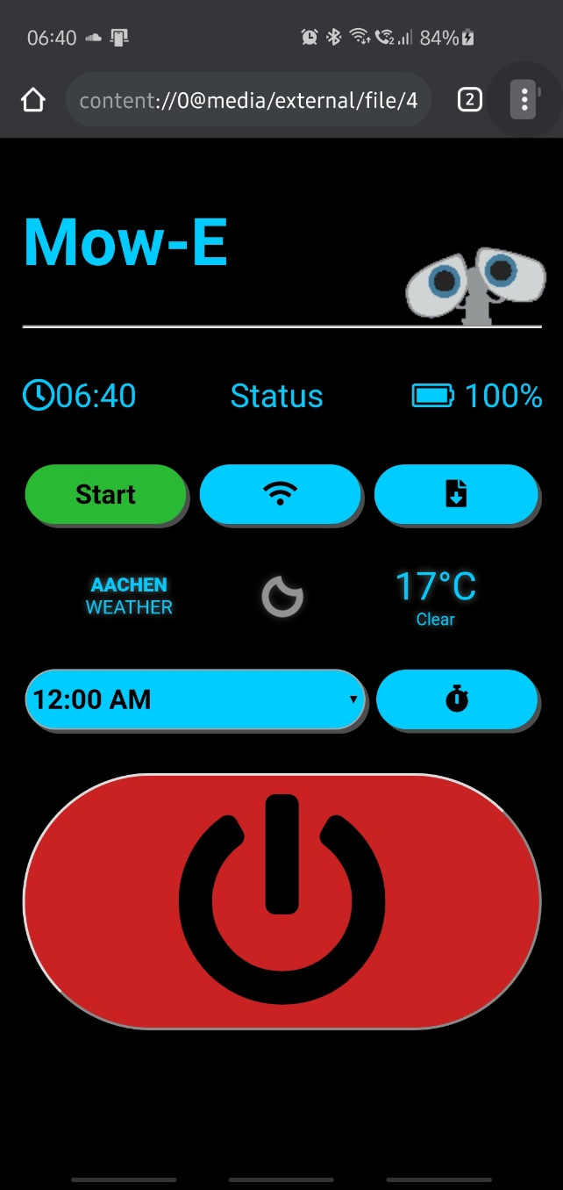

All the features and convenience of the Desktop UI can be accessed via smartphones as well using the mobile version of the html file. All the functions and features of the Desktop UI work exactly the same way on the mobile version. The mobile version, thus, offers an even more convenient and handy alternative for operating Mow-E remotely.

Now you’re fully equipped and ready to mow!

*For any component or internal programming issues, refer to the documentation for mechanical, electrical and software information.

# Troubleshooting

**Bot:**

1. Boot Failure:

Check switch connections

Check for switch damage

Make sure the battery is fully charged

Check battery connections

Check for wet surfaces/dirt particles in battery container

1. Blank Display/ Readout Failure:

Check LCD connections

Check for damage to LCD pins

1. Keypad Input Failure:

Check keypad connections

Check for individual key damage

1. Wheels Rotation Failure:

Check battery level

Check wheel to motor connection

Check wheel damage

Check motor damage

Check for dirt particles between wheel and motor

1. Obstacle/Boundary Detection Failure:

Check IR Sensor damage

Check Ultrasonic Sensor damage

Check connection to sensors

Check connections on Arduino

Ensure black tape is placed on IR Sensors

Clean the surface of the sensors

**Web App:**

1. Unresponsive buttons:

Reload HTML page

Check internet connections

Check web browser settings

Use standard web browser (Mozilla Firefox, Chrome, Safari, Microsoft Edge)

1. Any function on App not working

Reload HTML page

Check internet connections

Ensure that bot is turned on

Check connections from battery to Node MCU

Check web browser settings

Press Connect to Server (WiFi symbol) button

Use standard web browser (Mozilla Firefox, Google Chrome, Safari, Microsoft Edge)

# Safety and Warnings

**Preparations**

* Inspect periodically the area where the mower is used and remove all stones, sticks, cones, wires and other foreign objects.
* Periodically visually inspect to verify that the blade is not worn or damaged. Replace a worn or damaged blade

**Operation**

* Do not attempt battery removal when Mow-E is in operation
* Do not dispose of the mower or any of its parts as unsorted municipal waste. They should be collected separately.
* Do not disassemble, short circuit, or expose to fire, or high temperatures
* Risk of electric shock
* Use in dry locations only
* Make sure that Mow-E is turned off before changing batteries to avoid damage to internal components
* Do not place any object between wheels, may cause damage to motor
* Keep away from children
* Do not operate the mower if any safety feature or any part is damaged, worn or inoperable.
* Keep hands and feet away from the cutting blade and other moving parts.
* Always switch off the Safety Switch before lifting it or planning to operate any adjustments.
* Never pick up or carry the mower while the motors are running.
* Do not touch the blade before it has completely stopped rotating.
* Do not use the mower for any purpose other than cutting lawn.
* Keep all guards, shields, safety devices, and sensors in place. Repair or replace damaged parts.
* Set the weekly program at times when there are no people on the grass.
* In the event of accident or breakdown whilst the mower is operating, immediately press the red STOP button.

**Batteries**

* Do not open or damage the battery pack.
* The Battery Pack contains electrolytes. In case of an electrolyte leakage from the Battery Pack, the following actions should be taken:

• Skin contact: Wash the contact areas off immediately with water and soap.

• Eye contact: Immediately flush the eyes with plenty of clean water for at least 15 minutes, without rubbing.

• Get medical assistance.

* Ensure that the battery is charged using the correct charger recommended by the manufacturer. Incorrect use may result in electric shock, overheating or leakage of corrosive liquid from the battery.
* Use of only AA batteries permitted, other types of batteries may burst causing injury to persons and damage to equipment

**Maintenance and special instructions**

* Always switch off the Safety Switch before clearing blockage/checking/cleaning/working on the mower, or after striking a foreign object to inspect the machine for damage. Never attempt to service or adjust the mower while it is in operation.
* In case of abnormal vibrations, stop the mower, switch off the Safety Switch and check for any damage of the blade. Replace a worn or damaged blade to preserve balance. If the vibration continues, call for service.
* Use heavy gloves when inspecting or servicing the blade.
* Do not perform maintenance barefoot or wearing open sandals. Always wear suitable work shoes and long trousers.
* Replace worn or damaged parts for your safety.
* Use only original equipment and accessories. It is not permitted to modify the original design of the mower. All modifications are made at your own risk.
* Ensure that only replacement cutting means of the right type are used.
* Keep all nuts, bolts and screws tight to be sure the machine is in safe working condition.